**2020.01.21 Exercise**

**<Training Set>**

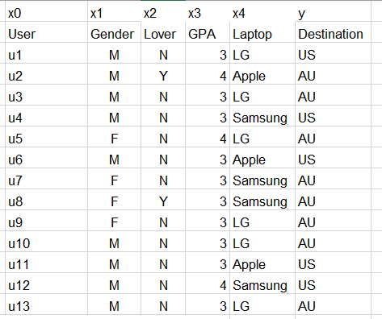

**<Model>**

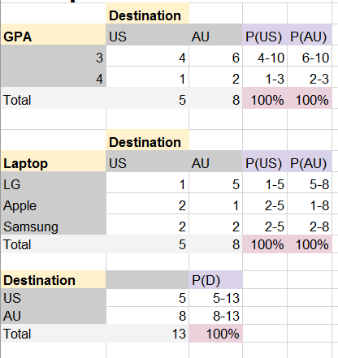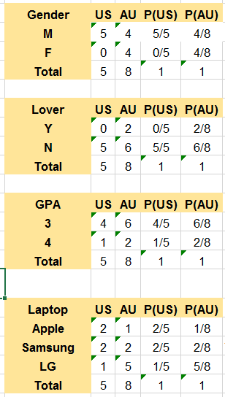

**<Testing set>**

1.

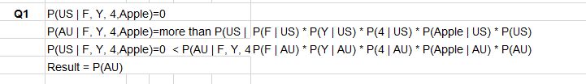

2.





3.





4.



